# Introduction

The LipSync is a mouth operated joystick that emulates a computer mouse using a combination of lip movements and sip and puff breath control via a straw-like mouthpiece. Not all users are able to use the mouthpiece to input sip and puffs. The LipSync Switch Input Module enables a user to utilize two assistive switches in place of the pressure sensor to control the sip and puff functions.

The LipSync Switch Input Module canSwitch Adapted LipSync is intended for users who may have difficulty with limited breath control, such as those on ventilators. The Switch Adapted LipSync can be used with a large variety of assistive switches that use the standard 3.5mm phono plug format.

# Commercial Options

Table Commercial Options

|  |  |  |  |
| --- | --- | --- | --- |
| **Name** | **Vendor** | **Cost** | **Link** |
| Jouse 3 | Compusult | CA$1,762.61 | https://www.compusult.com |
| TetraMouse Model TMXA2 | TetraMouse | $449 | https://tetramouse.com |
| QuadJoy | QuadLIFE | $1,190.00 USD | https://quad.life/products-builder/p/style-02-56paj |
| The 'Sup’ | None (DIY Open Source) | $50 USD | https://www.instructables.com/The-Sup-a-Mouse-for-Quadriplegics-Low-Cost-and-Ope/ |

# Switch Adaption Choice

Existing commercial LipSync equivalents such as Tetramouse and QuadJoy already offer switch adaption options, so it seemed natural to offer an augmentation that would provide this benefit to our Lipsync users.

## External Jack Interface

The inspiration for the Switch is the ‘External Jack Interface’ From QuadLIFE. It provides three 3.5 mm assistive jacks.

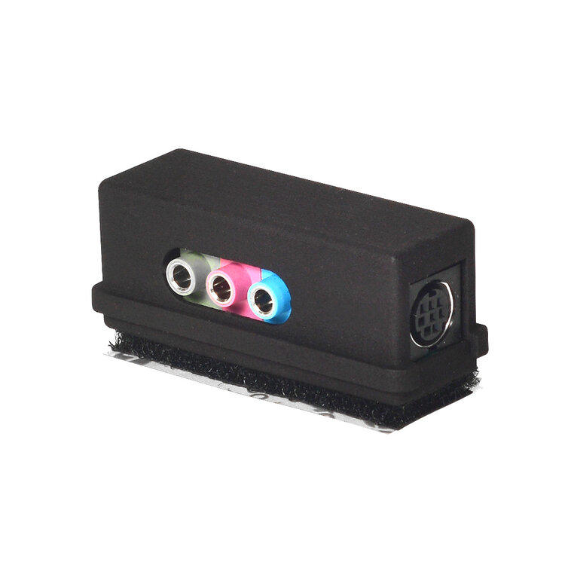

# Design Considerations

The goal for this version was to create a module that required minimal changes to the LipSync hardware and firmware.

To keep redesign of the LipSync to a bare minimum, the Switch Adapted LipSync module must fit the same connector and same general size footprint of the original pressure sensor daughterboard of the LipSync. Additionally, the Switch adaptation would need to mimic the functionality of this pressure sensor board, so that no (or minimal) firmware changes would be required to support this addition.

# Circuit Design

The choice was made to simulate the pressure sensor, so that no, or minimal, coding changes to the LipSync firmware would be required. The behavior of the pressure sensor is a straightforward transistor “totem pole” style output analogous to a voltage divider. The pressure sensor output voltage is half the supply voltage when no air pressure is applied through the sip and puff straw. Pumping air into the straw causes the voltage to drop and conversely, sipping air from the straw causes the voltage to increase. The decision was made to use two 100K resistors as a weak voltage divider. The switches would be placed in parallel with the two resistors. When a switch is activated it shorts out the resistor that it's in parallel with. Shorting out the lower resistor causes the voltage on the output to drop. This mimics ‘puff’ operation from the pressure sensor. Shorting out the upper resistor causes the output voltage to rise, which mimics ‘sip’ operation. While the two resistor circuit does all that’s required to satisfy the basics of mimicking a pressure sensor, the decision was made to add a second pair of resistors (10K value) to limit the current in the switch circuit. These resistors would ensure accidental wiring faults would not allow a short circuit of the Lip Sync USB power supply, and help absorb unwanted stray static charges.

|  |  |
| --- | --- |
|  |  |

*Figure 1: Switch Modification Ideation*

*Figure 2: Early Prototypes*

*Figure 3: Early Prototypes: underside view*

# Concept Testing

A pair of prototypes was constructed, on proto board, to test the basic premise of the circuit design. In the first prototype the original pressure sensor was left in place with a resistor added to protect it. then two switchers were soldered across this protected sensor output line. The LipSync was then powered up, and the joystick navigated to an icon desktop. Clicking on the lower button highlighted the icon, and clicking on the upper button, opened a menu on the desktop. All of these were expected behaviors for normal sip and puff operation on a Lip Sync.

# Version 1.1 Changes

This section will cover the changes and updates that was discussed in the previous section. The design changes focus more on improving the earlier design.

# 3D Printed Version

The usage of 3-D printing technology allows for low-cost production of the Switched LipSync with a minimum of parts. 3D also eliminates the need to cut or file potentially hazardous PCB material (fiberglass dust). Additionally, the 3-D print incorporates a circuit board, cable strain relief mounting and supporting header connector, all of which would have to be obtained separately, or custom built, if 3-D printing were not used.

|  |  |
| --- | --- |
|  |  |

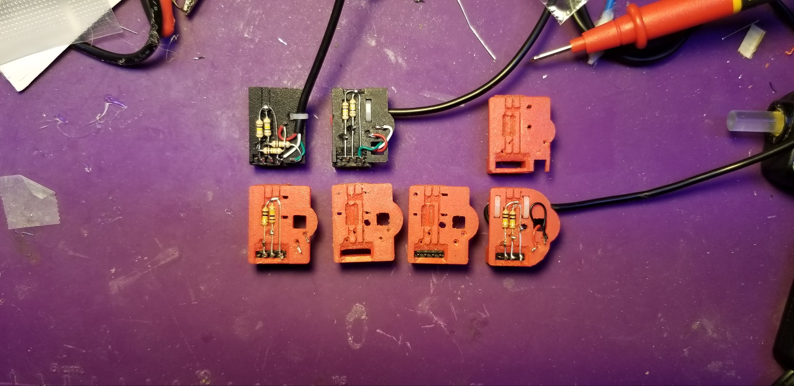

# A Series of 3D Prototypes

During a meeting, the decision was made to construct the switch adapter using 3-D printing technology, as most makers now have access to this technology. 3-D printing offered a number of advantages. Firstly, it eliminated the need to purchase or fabricate a circuit board, or maintain inventory. Secondly, a header connector, and a cable strain relief, could be incorporated into the design, keeping costs low, by minimizing additional parts that would otherwise have to be sourced. To test the idea that a 3-D printed circuit board would work, a 3-D model was designed in OpenSCAD, a free, open source, code based modelling app. For simplicity, the first model incorporated all resistors on the top side of the circuit board. The result was functional, but crowded. The decision was then made to move the current limiting resistors to the underside of the design. With some feedback from our group of testers, we also reinforced the strain relief, slightly widened the header holes to allow for easier module installation, and added a central hole to keep the shield wire from coming into contact with the other wires. The final change was rounding the back end of the module so that it wouldn't touch the case of the LipSync.

# Switch Adapter Top Side



On the finalized switch adapter, you can see the main voltage divider resistors soldered to the header (lower black object) and the Tip and Ring wires (Black and red respectively). The Back end of the adaptor module is rounded to fit within the narrower back end of the LipSync case. The bulky ends of the cable ties have been relegated to the bottom side to avoid snagging.

# Switch Input Module Bottom

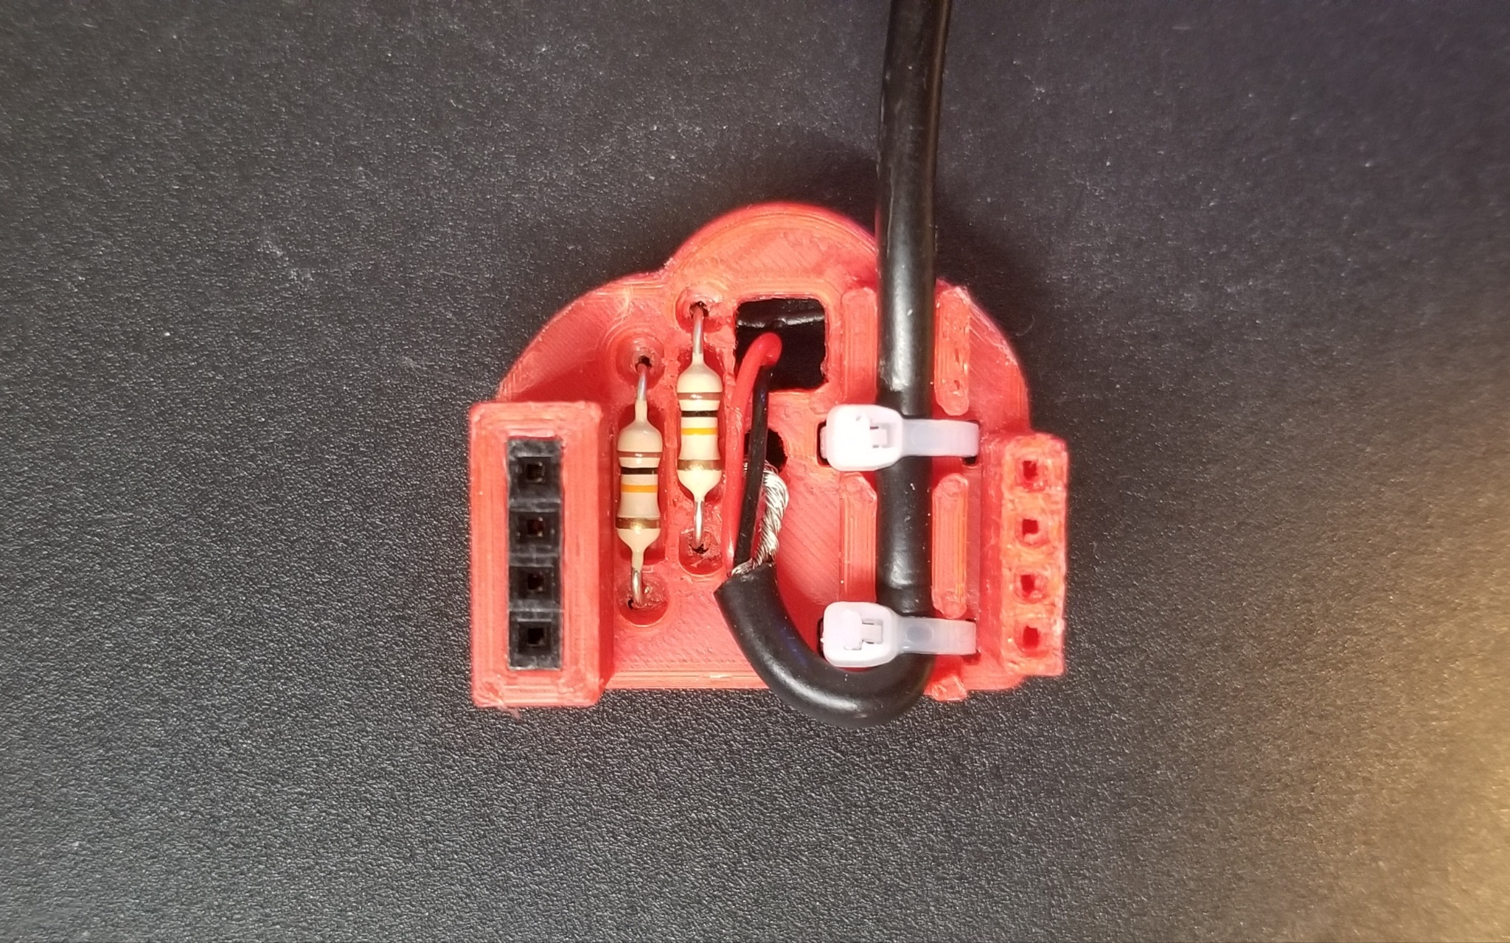

Figure : Bottom of Switch Input Module

The bottom side of the switch adapter shows the connector side of the inserted female header (top of image) and the two current limiting resistors (10K). The female 3.5mm jack stereo cable enters the adaptor (bottom right) where it is held firmly in place by two small cable ties. From there, the cable loops up and to the right, where the sleeve wire emerges from the cable, and enters the small hole, to connect to the center of the voltage divider. The Tip and Ring wires (Black and red respectively) enter the larger square hole, to connect with the current limiting resistors, where their wires emerge on the top side of the board.

# Testing

## Cord Testing

|  |  |
| --- | --- |
|  | The Switch Input Module Cord was tested for mechanical strength. Specifically, the cord was tested to ensure the mounting was robust enough to withstand being pulled in ways that might occur during real world use.  Initially, we chose to secure the LipSync cord and drop the LipSync using its own weight. The cord mounting survived up to a 120 cm drop before scuffing to the cord was observed. As a final “torture test”, we taped the LipSync to a metal support frame, and attached a 2.2 Kg (5lb) mass to the cord. This was dropped 30 cm, causing the header pins on the LipSync to bend, but the Switch Adaptor and cord remained intact and functional. This was considered satisfactory, as it suggested the adaptor and cord were more rugged than the LipSync itself. |